Calculating marginal impact based on the Exposed Limit Job:
Method :1
Step 1: Setting up the default marginal impact analysis in the portfolio:
- Create a new attribute “Allow to modify marginal impact analysis” in the authorization mode; set this to true only for Admin mode so admin user can select portfolio exposed limit analysis as the base analysis for marginal impact analysis.
- When user is already in
  - Portfolio Mode
  - In Exposed limit analysis result
  - Peril Mode
  - Has “Allow to modify marginal impact analysis” in the authorization as True
Add a new Icon below “Default portfolio icon” that will allow user to set the default. Create a new database table to store this information. We want to keep the structure flexible so we can have defaults in future based on the branch.
The database table should have following items –
ID, Branch name = default all for now, dateModified, AnalysisType = default “Exposed limit” , PerilCode, PortfolioID, analysisID, analysisName, exposedlimitFileName or exposedlimitinfoID, DamageRatioFileName, IsDeleted = default 0
For every branch, there should only be one record in the database. So if user decides to add a new portfolio analysis per peril, we should change Isdeleted = 1 and add the new entry for the new analysis. Show the notification in the right corner to inform user that the default has been successful.
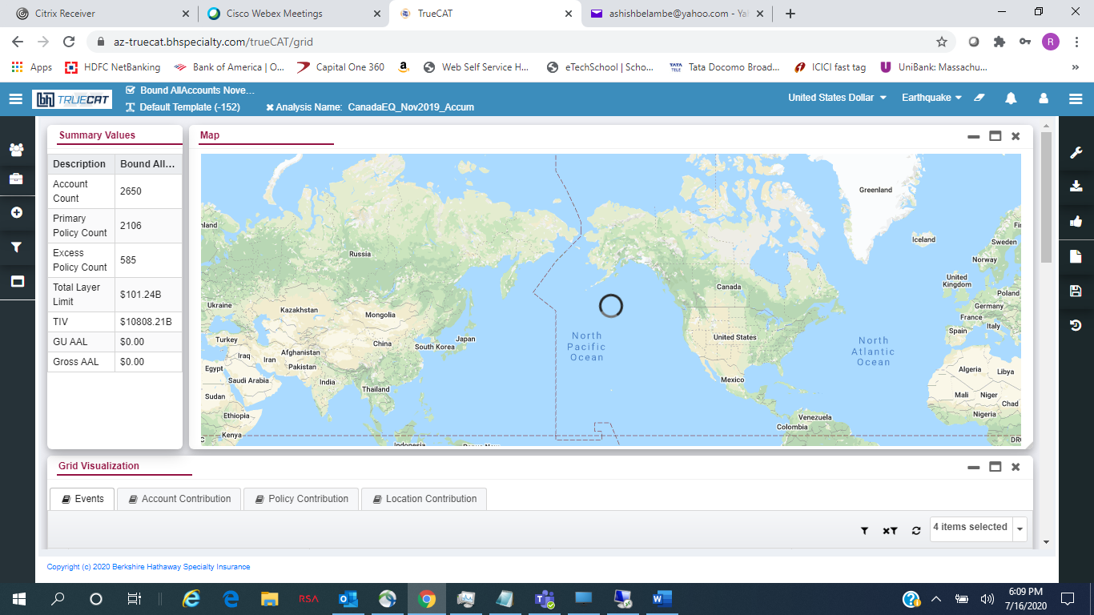

Once the analysis is set as a default, the admin will need to use the feature that allows admin user to expose the “exposed limit file” and the associated damage ratio file to underwriters. They will need to ensure that the names are same. We can also automatically call this API from once the default change is successful and make sure this same exposed limit file/damage ratio is visible to underwriter.
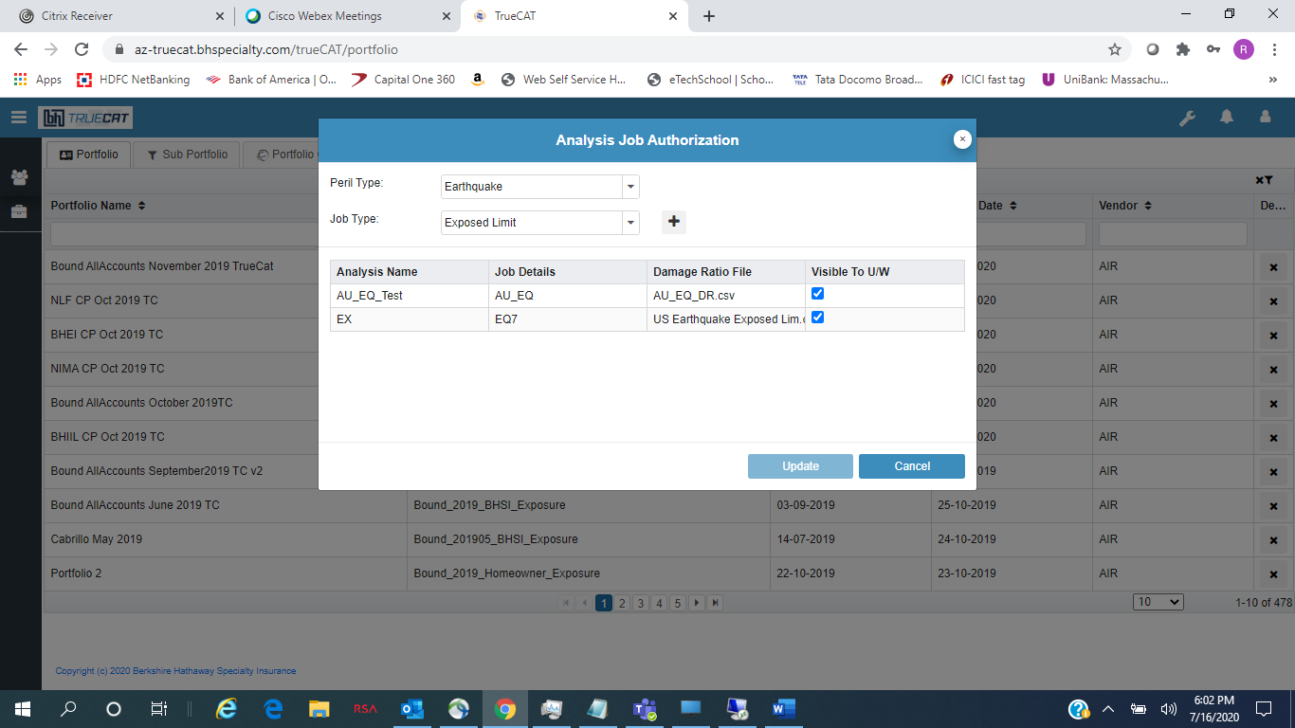
The underwriter will run the exposed limit analysis
Step 2: Underwriter running the exposed limit analysis on individual account:
- We need to make sure that the exposed limit file and damage ratio file (or 100%) is same between the two analysis. We already have this working as expected and no change is needed in this functionality
Step 3: Showing the marginal impact results in the TrueCAT UI and Excel export
We will show all the exhibits as today for exposed limit analysis. We will add following grid visualization as additional tab in the TrueCAT UI. This needs to be done for:
- Perils only and should not be shown for summary
- Exposed limit analysis only
- If there is a default analysis set in the step 1 for this peril and underwriter branch and Default exposed limit file name and damage ratio file name is same between the two analyses; if it is not there, don’t show the additional tab
Don’t show losses for “Program limit xs layer” layer. In addition to visible columns below, we should add following columns – company share, layer amount and attachment from the layers table.
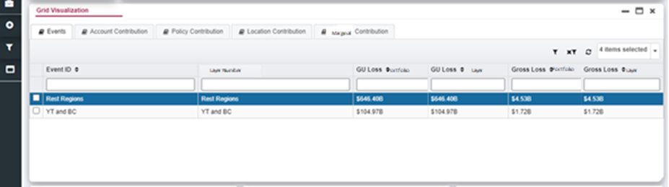
On Azure production, we can use following query:
USE ARAPL_Configuration

--SELECT * FROM hpcJobs where analysisMode = 'Portfolio' and exposedlimitinfoID =3
--SELECT * FROM hpcJobs where analysisMode = 'Account' and exposedlimitinfoID = 3
DECLARE @AcctSrNo int
DECLARE @sourceDBName nvarchar(255)
DECLARE @AccountName nvarchar(255)
DECLARE @PolicyTableName nvarchar(2550)
DECLARE @strSQL nvarchar(2550)

SELECT @AcctSrNo= AccPortSrNo
FROM hpcJobs where analysisMode = 'Account' and exposedlimitinfoID = 3 and jobID = 2420

PRINT @acctsrNo
SELECT @sourceDBName=sourceDB,@AccountName = AccountName FROM ARAPL_Configuration..CompletedAccounts where SrNo = @AcctSrNo
PRINT @sourceDBName
PRINT @AccountName

SELECT @PolicyTableName = ARAPL_Data.[dbo].[ConstructBaseTableName] (@SourceDBName,@accountName + '_Policy')
PRINT @PolicyTableName
DROP TABLE #tmp
SELECT
EventId, SUM(TotalGroundUPLoss) as Portfolio_GU, SUM(TotalPolicylossAmount) as Portfolio_GR
into #tmp
FROM ARAPL_Analysis..PolicyLevelLoss_2349
GROUP BY eventID

SET @strSQL = '
SELECT t.eventID, p.policyNumber,p.companyShare,p.LayerAmount, p.attachmentPoint, Portfolio_GU,TotalGroundupLoss as Layer_GU, Portfolio_GR,TotalPolicyLossAmount as Layer_GR
FROM ARAPL_Analysis..PolicyLevelLoss_2420 pl
inner join ARAPL_Data.'+ @PolicyTableName + ' p on pl.policyID = p.policyID
right join #tmp t on t.eventID = pl.eventID
WHERE PolicyNumber NOT LIKE ''%ProgramLimit Xs Ded%''
order by PolicyNumber, totalPolicyLossAmount DESC '

PRINT @strSQL

EXEC sp_executeSQL @strSQL

Calculating marginal impact analysis based on the all job type:
Method :-2

Step 1: setting up the default marginal impact analysis in the account:
- Expand the marginal impact calculation for all the job types including shape, ring and custom shape
- Select first account tab and then select the job type add default checkbox for marginal impact
- Select the portfolio/sub portfolio in dropdown list and submit the job or
- Create new popup window for same as the create new portfolio group in this popup show the portfolio and subportfolio unique list and shows the create date, sorting order, pagination etc.
- We should bring all the information related portfolio required to submit the job when we show the portfolio drop down list; On submit, we should submit both account and portfolio jobs to TrueCAT
- Expand hpcjobs table to add the portfolioJobID for marginal impact analysis
- Default checkbox should be turned off
- This section should appear only for account modeling and not for portfolio

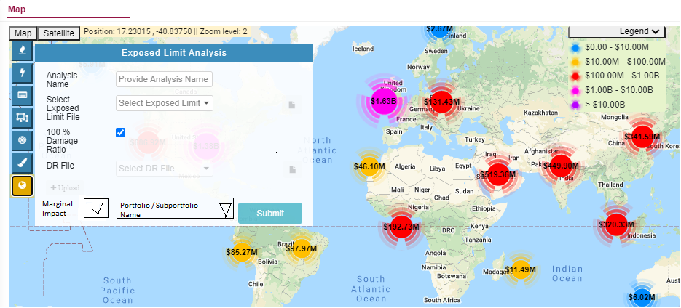

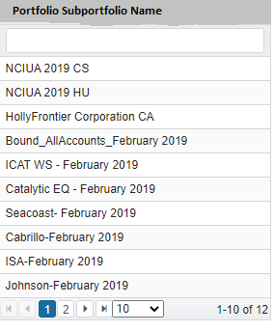

Step 2: Showing the marginal impact results in the TrueCAT UI and Excel export
We will show all the exhibits as today for all type of analysis. We will add following grid visualization as additional tab in the TrueCAT UI. This needs to be done for:
- Perils only and should not be shown for summary
- All types of jobs show
- Change the process to look at this JobID to get portfolio loss information when we show marginal impact tab in the results section; if the portfolio job is still running, don’t show the marginal impact tab; also we should show the marginal impact portfolio name somewhere on TrueCAT UI
Don’t show losses for “ProgramLimit xs layer” layer. In addition to visible columns below, we should add following columns – company share, layer amount and attachment from the layers table.
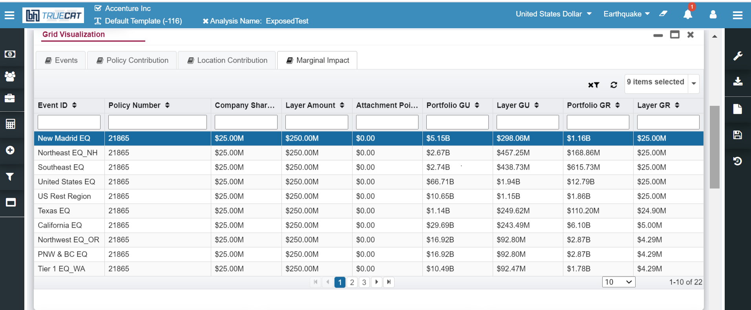

1.Shape Analysis
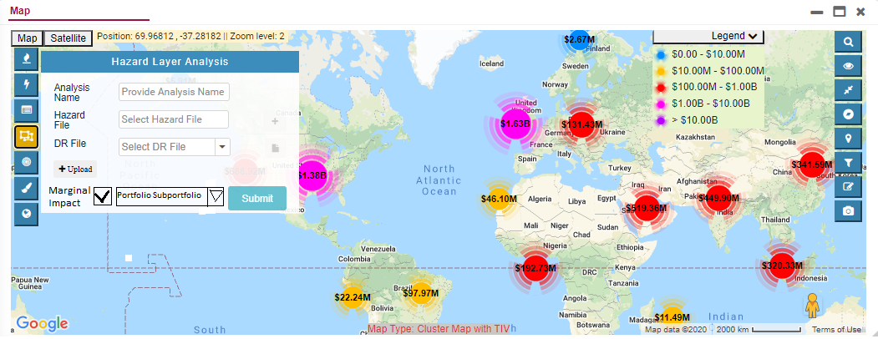
2.Ring Analysis
1.Manual Mode
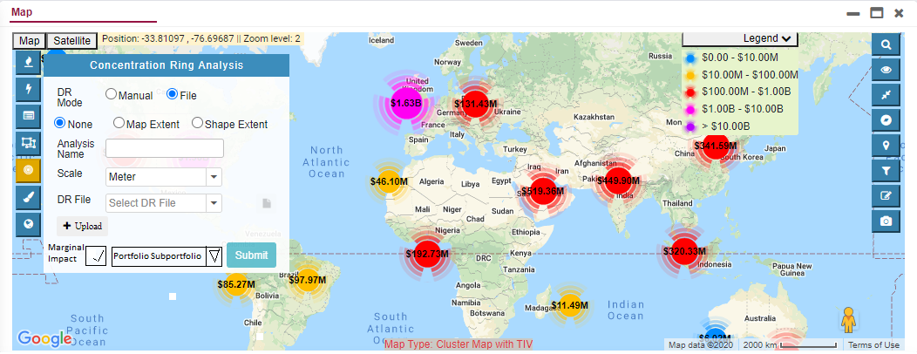
2.File Mode

3.Custom Shape Analysis
1.Manual Mode
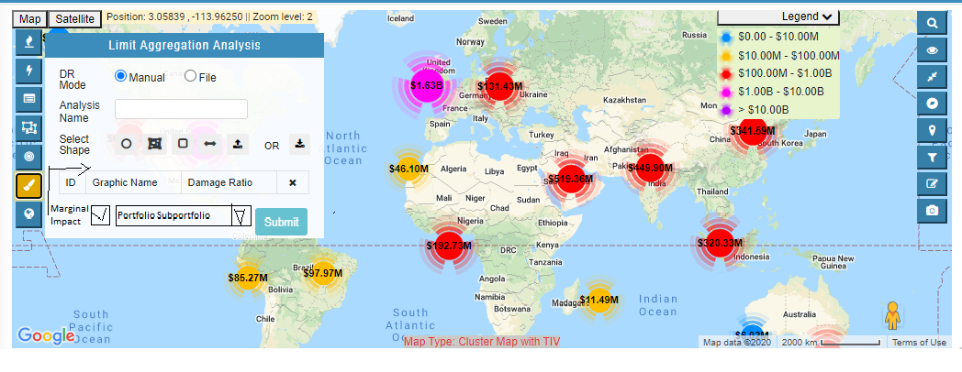2.File mode
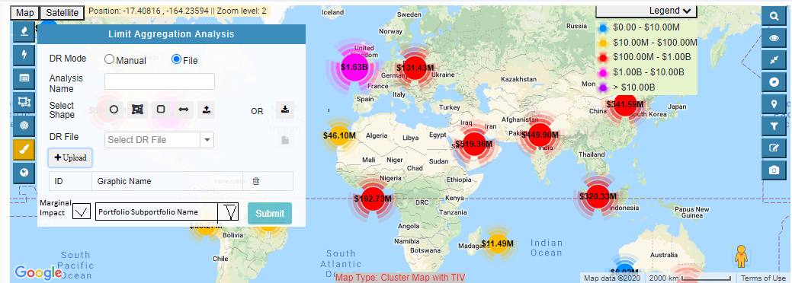
Step 3: Showing the marginal impact analysis in DB Side structure
We will show all type of analysis in the db table in default, HPC job table. There are 3 types of scenarios save in db tables
- Default checkbox should be turned off
This section should appear only for account modeling and not for portfolio

- Default checkbox should be turned on
- This section should appear for account modeling as well as portfolio and by default first check the default job table same job entry is already present then hpcjob table add only portfolio job id run only account job and show the marginal impact column

- Default checkbox should be turned on but job entry is not present
- First check the default job table job entry is not present then add portfolio job id in hpcjob table first run the portfolio job and then add the account job entry and also run the account job then check the marginal impact column in account job details
DefaultJobs Table
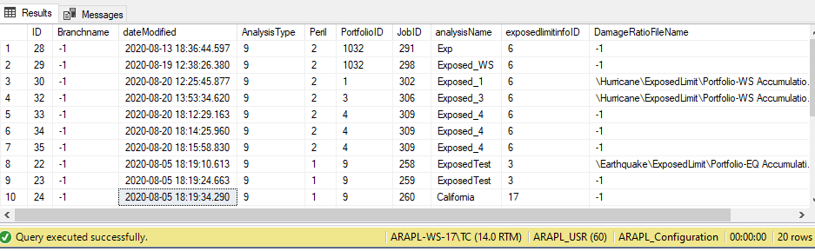

HPCJobs
- Expand hpcjobs table to add the portfolioJobID for marginal impact analysis

